Hello!

We’ve found a common problem that students often complains during the distance learning, that is, when students tackle with various of lessons they choose, they usually don’t have that much time to dig out those tabs from history or bookmarks, and that surely wastes a plenty of time of students including me.

Therefore, we invented this little but powerful project that dedicated to solve this problem and meet different needs.

Start running the program:

Run “MainWindow.java:

MainWindow:

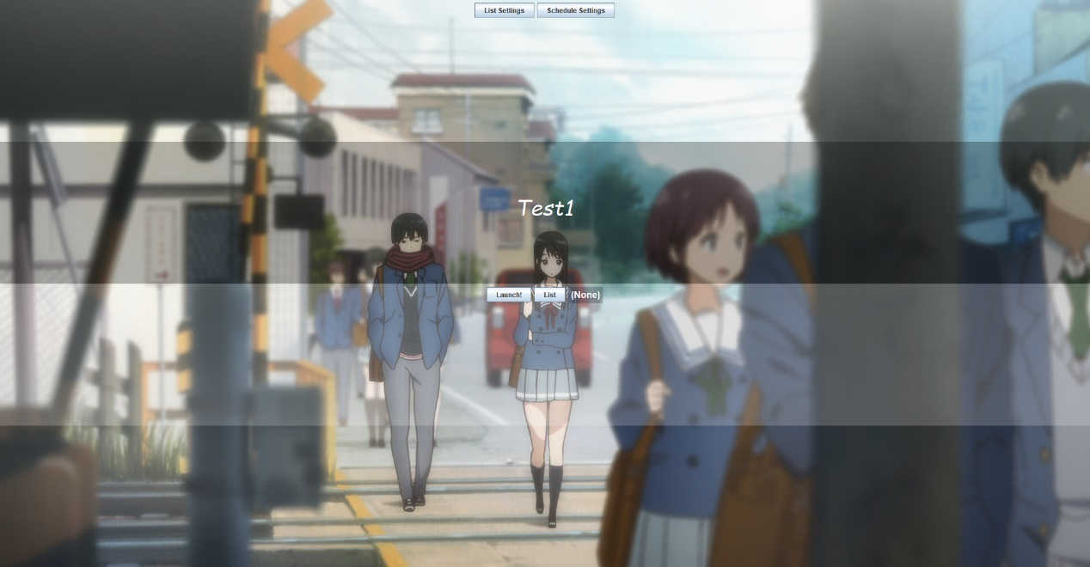

The background is a random picture. You can also add your own picture into the folder “BackPictures” in the project folder.

At the middle of the window is a random literary/educational sentence. You can also add your own content in the .txt file “Sentences.txt” in the project folder.

“List” button allows you to choose a list of websites you set before, and then press “Launch” It will directly help you open these websites immediately.

Top left:

List Settings:

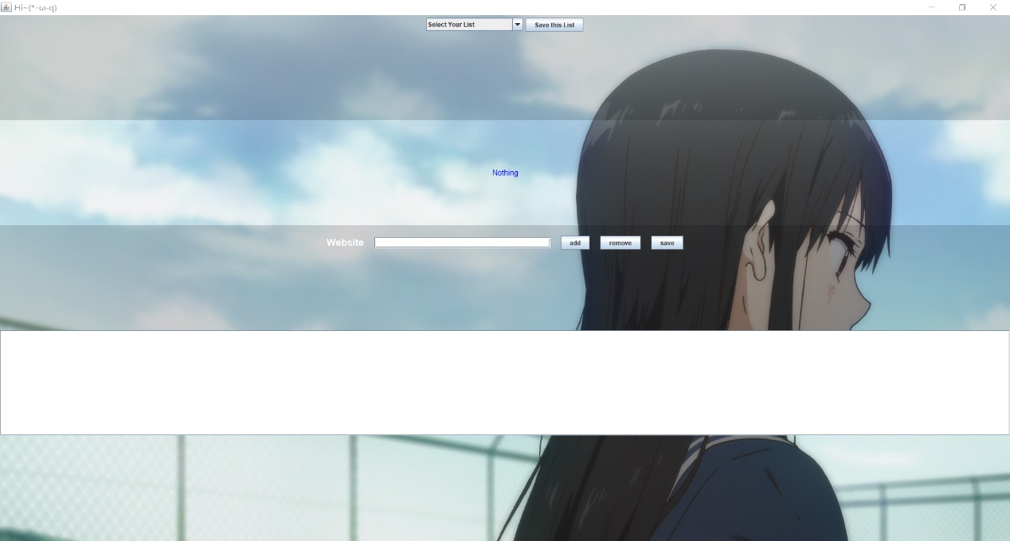

From top to the bottom:

1. Select your list: a menu that allows you to browse the existing site lists(including trash bin), when you select an existing list and did some changes to the list, you can press “Save this list” to save the changes.
2. “Nothing”: this is the status panel, it will change as you operate other functions.
3. Website: you can type in whatever you like in it and press “enter” to add it to the list under it (the blank), you can also click “add” to do so. When you select an element in the list under it and click “remove”, it will just disappear from the list. If you decide to save this list of websites , press “save” button and then it will ask you to enter a name, if you press “cancel”, the name will be null, and do not enter repeated names.

The websites you discard won’t disappear, rather, they will be thrown into the file trash.txt, you can find them and recover them.

Schedule settings:

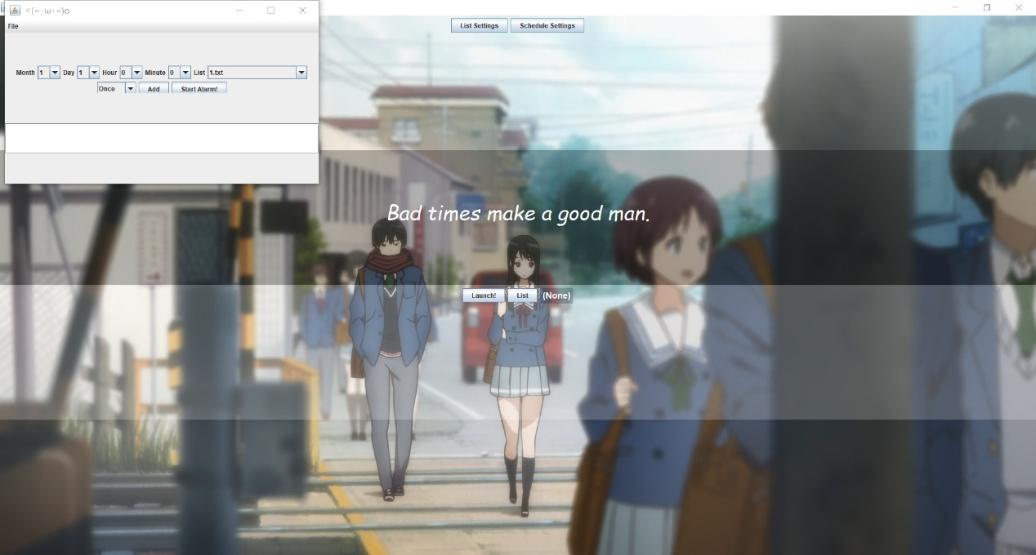

A control panel that allows you to set a “clock” to decide on what time which websites you would like it to open automatically.

Press “add” to create a new clock in the list.

There are several modes: open once, open daily, open weekly and open monthly , you are also allowed to choose the list you set before, it’s also acceptable to open the trash bin.

Different clocks can operate in different modes, however, once you press “Start Alarm”, there’s no looking back unless you quit the program and recreate these clocks.

To deal with this problem, you can export your current list as a file and it will be saved in the “ClockList” folder under your project folder. And you can also get back your list by importing them. Caution: Don’t expect to understand the txt file.

,

As